Y3  2025-2026 | Autumn |  | Spring |  | Summer
Maths | - Adding and Subtracting through 10  - Numbers to 1000 |  | - Right Angles  - Manipulating the additive relationship and securing mental calculation  - Column Addition  - 2, 4, 8 Times Tables  - Column Subtraction |  | - Unit Fractions  - Non-Unit Fractions  - Parallel and Perpendicular sides in Polygons  - Time
English | Mixed Genre Writing: Mini Rabbit Not Lost  Mixed Genre Writing: Ulf and the Finger Eater  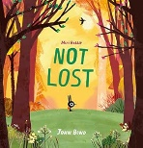  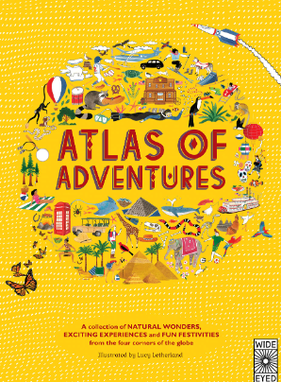 | Mixed Genre Writing: Rachel Bright and Jim Field  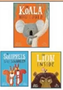  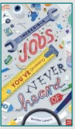  Mixed Genre Writing: Incredible Jobs You’ve (Probably) Never Heard Of | Non-Chronological Reports: Ancient Egypt  Poems by the Same Poet: Michael Rosen | Mixed Genre Writing: The Bear and the Piano  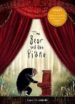  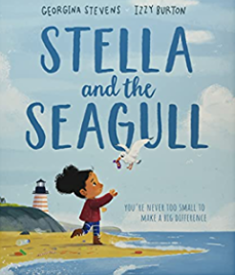  Persuasive Texts: Stella and the Seagull | Information Texts: Atlas of Adventures  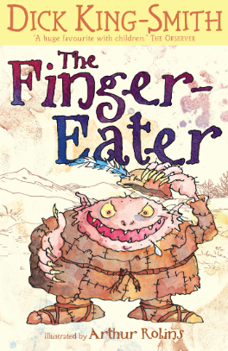  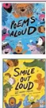  Poems Aloud Smile Out Loud | Mixed Genre Writing: The Incredible Book Eating Boy  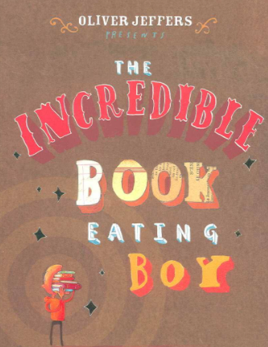  Poetry Free Verse: The Magic Box Kit Wright
Science | Light  National Curriculum:  - recognise that they need light in order to see things and that dark is the absence of light  - notice that light is reflected from surfaces  - recognise that light from the sun can be dangerous and that there are ways to protect their eyes  - recognise that shadows are formed when the light from a light source is blocked by an opaque object  - find patterns in the way that the size of shadows change | Forces and Magnets  National Curriculum:  - compare how things move on different surfaces  - notice that some forces need contact between 2 objects, but magnetic forces can act at a distance  - observe how magnets attract or repel each other and attract some materials and not others  - compare and group together a variety of everyday materials on the basis of whether they are attracted to a magnet, and identify some magnetic materials  - describe magnets as having 2 poles  - predict whether 2 magnets will attract or repel each other, depending on which poles are facing | Rocks  National Curriculum:  - compare and group together different kinds of rocks on the basis of their appearance and simple physical properties  - describe in simple terms how fossils are formed when things that have lived are trapped within rock  - recognise that soils are made from rocks and organic matter |  | Plants  National Curriculum:  - identify and describe the functions of different parts of flowering plants: roots, stem/trunk, leaves and flowers  - explore the requirements of plants for life and growth (air, light, water, nutrients from soil, and room to grow) and how they vary from plant to plant  - investigate the way in which water is transported within plants  - explore the part that flowers play in the life cycle of flowering plants, including pollination, seed formation and seed dispersal | Animals including Humans  National Curriculum:  - identify that animals, including humans, need the right types and amount of nutrition, and that they cannot make their own food; they get nutrition from what they eat  - identify that humans and some other animals have skeletons and muscles for support, protection and movement
History | Stone Age  National Curriculum: changes in Britain from the Stone Age to the Iron Age  Disciplinary focus: evidential thinking  What can sources reveal about Stone-Age life? |  | Ancient Egypt  National Curriculum: the achievements of the earliest civilisations  Disciplinary focus: change/continuity  How much did Ancient Egypt change over time |  | Ancient Greece and Alexander the Great  National Curriculum: a study of Greek life and achievements and their influence on the western world  Disciplinary focus: evidential thinking  What can historians learn from the sources from Ancient Greece
Geography | Agriculture  National Curriculum:  - name and locate counties and cities of the United Kingdom, geographical regions and their identifying human and physical characteristics and land-use patterns  - describe and understand key aspects of human geography including the distribution of natural resources including food  - use filed work to observe, measure and record and present the human and physical features in the local area  Disciplinary focus: interaction  How are we connected to farmers?  Skills focus: local fieldwork investigating local shops – their sourcing, economic and ethical considerations |  | Rivers (incl. Rhine and Mediterranean)  National Curriculum:  - describe and understand key aspects of physical geography (rivers and the water-cycle)  - name and locate key topographical features (rivers) and land-use patterns  Disciplinary focus: interaction  How do rivers people and land affect each other?  Skills focus: using photographs |  | Mountains  National Curriculum:  - name and locate key topographical features (mountains)  - describe and understand key aspects of physical geography (hills and mountains)  - use the 8-points of a compass  Disciplinary focus: interaction  How do mountains and people affect each other?  Skills focus: describing location using 4-point compass
PE | OAA  National Curriculum:  - take part in outdoor and adventurous activity challenges both individually and within a team | Ball Handling  National Curriculum:  - use running, jumping, throwing and catching in isolation and in combination | Ball Skills  National Curriculum:  - play competitive games, modified where appropriate [for example, badminton, basketball, cricket, football, hockey, netball, rounders and tennis] | Tri Golf  National Curriculum:  - play competitive games, modified where appropriate [for example, badminton, basketball, cricket, football, hockey, netball, rounders and tennis], | Athletics  National Curriculum:  - develop flexibility, strength, technique, control and balance | Striking and Fielding  National Curriculum:  - apply basic principles suitable for attacking and defending
PE | Dance  National Curriculum:  - perform dances using a range of movement patterns | Gymnastics  National Curriculum:  - develop flexibility, strength, technique, control and balance | Gymnastics  National Curriculum:  - develop flexibility, strength, technique, control and balance | Dance  National Curriculum:  - perform dances using a range of movement patterns | Dance  National Curriculum:  - perform dances using a range of movement patterns  - compare their performances with previous ones and demonstrate improvement to achieve their personal best | Gymnastics  National Curriculum:  - develop flexibility, strength, technique, control and balance  - compare their performances with previous ones and demonstrate improvement to achieve their personal best
Art | Paper Sculptures  National Curriculum:  Pupils should be taught to develop their techniques, including their control and their use of materials, with creativity, experimentation and an increasing awareness of different kinds of art, craft and design.  Pupils should be taught:  - to create sketch books to record their observations and use them to review and revisit ideas  - to improve their mastery of art and design techniques, including drawing, painting and sculpture with a range of materials [for example, pencil, charcoal, paint, clay]  - to know about great artists, architects and designers in history.  - Shape, form, model and construct with malleable and rigid materials.  - Develop different joining techniques to the purpose, medium and aesthetics.  - Make initial sketches to inform making. |  | Printing  National Curriculum:  Pupils should be taught to develop their techniques, including their control and their use of materials, with creativity, experimentation and an increasing awareness of different kinds of art, craft and design.  Pupils should be taught:  - to create sketch books to record their observations and use them to review and revisit ideas  - to improve their mastery of art and design techniques, including drawing, painting and sculpture with a range of materials [for example, pencil, charcoal, paint, clay]  - to know about great artists, architects and designers in history.  - Create impressed and relief designs to print with and experiment with mono-printing.  - Experiment with repeating patterns and overlapping colours. |  | Painting: Flowers  National Curriculum:  Pupils should be taught to develop their techniques, including their control and their use of materials, with creativity, experimentation and an increasing awareness of different kinds of art, craft and design.  Pupils should be taught:  - to create sketch books to record their observations and use them to review and revisit ideas  - to improve their mastery of art and design techniques, including drawing, painting and sculpture with a range of materials [for example, pencil, charcoal, paint, clay]  - to know about great artists, architects and designers in history.  - Apply colour using wash, dotting, splatter, scratching etc in addition to more traditional methods.  - Refine colour mixing skills, producing colour wheels or multiple tints of a single colour.  - Create colour references in sketch books  - Refine skills in figurative and abstract work, selecting colours to reflect mood.
DT | Structures  Key Skills, Knowledge and Understanding:  - know how to make strong, stiff shell structures  - know how to use learning from mathematics to help design and make products that work  - develop and use knowledge of nets of cubes and cuboids and, where appropriate, more complex 3D shapes  - select and use appropriate tools to measure, mark out, cut, score, shape and assemble materials with some accuracy  - explain their choice of materials according to functional properties and aesthetic qualities  - to apply a range of finishing techniques, including those from art and design, with some accuracy  - know about the work of more than one structural engineer. (e.g. Isambard K-B, Gustave Eiffel, Peter Rice, Falzur Khan) |  | Textiles: Fashion Accessories  Key Skills, Knowledge and Understanding:  - understand how to securely join two pieces of fabric together using appropriate stitching (e.g. running stitch, backstitch)  - select the most appropriate techniques to decorate textiles  - know that a single fabric shape can be used to make a 3D textiles product  - know how to strengthen, stiffen and reinforce existing fabrics  - select fabrics and fastenings according to their functional characteristics (e.g. strength and aesthetic qualities)  - know about the work of Milliner Rachel Trevor Morgan |  | Food and Nutrition: Greek Dips  Key Skills, Knowledge and Understanding:  - understand the principles of a healthy diet  - know that to be active and healthy, food and drink are needed to provide energy for the body  - understand where food comes from  - know that different combinations of ingredients can affect the taste and texture of a product  - prepare ingredients safely and hygienically using appropriate utensils, use juicer, garlic press, grate firmer foods, cut medium resistance foods into evenly sliced parts using bridge or claw method, snip/shred leaves, peel, spread, mix  - understand how a key chef, Dan Barber, has tried to impact the food industry as part of the ‘Farm to table’ movement
Music | Whole-Class Instrument: Ocarinas  Introduce Book 1  National Curriculum:  - Play and perform in solo and ensemble contexts, using their voices and playing musical instruments with increasing accuracy, fluency, control and expression  - Use and understand staff and other musical notations |  | Composition Notation – Ancient Egypt  National Curriculum:  - play and perform in solo and ensemble contexts, using their voices and playing musical instruments with increasing accuracy, fluency, control and expression  - improvise and compose music for a range of purposes using the inter-related dimensions of music  - listen with attention to detail and recall sounds with increasing aural memory  - use and understand staff and other musical notations  - appreciate and understand a wide range of high-quality live and recorded music drawn from different traditions and from great composers and musicians  - develop an understanding of the history of music. |  | Mountains  National Curriculum:  - play and perform in solo and ensemble contexts, using their voices and playing musical instruments with increasing accuracy, fluency, control and expression  - improvise and compose music for a range of purposes using the inter-related dimensions of music  - listen with attention to detail and recall sounds with increasing aural memory  - develop an understanding of the history of music. | Music Technology Unit  Spooky Story  National Curriculum:  - improvise and compose music for a range of purposes using the inter-related dimensions of music
PSHE | Beginning and Belonging  MMR 9  BB 3/4 | Family and Friends  MMR 11  FF 3/4  Anti-Bullying  MMR12 AB 3/4 | Diversity and Communities  CIT 7  DC 3/4 | SRE  HSL 13  SR 3 | Personal Safety  HSL 16  PS 3/4 | Managing Change  MMR 13  MC 3/4
RW | Hinduism: A Hindu Story, Rama and Sita  What does the story of Rama and Sita mean to Hindu peoples? | Hinduism: More Hindu Stories  What do Hindus learn from Vishnu’s stories and symbols? | Hinduism: Living Hindu Traditions  How do Hindus show their devotion? | Judaism: Abraham, Isaac, Jacob  Why is the promised land so important in Judaism? | Judaism: Joseph, Moses and the Exodus  Why do Jews celebrate the festival of Passover? | Judaism: The Kings the Temple and living as a Jew  How do Jews today show the importance of the Jewish Temple and the kingdom of Israel?
Computing | Online Safety  National Curriculum:  - use technology safely, respectfully and responsibly  - recognise acceptable/ unacceptable behaviour  - identify a range of ways to report concerns about content and contact | Computing Systems and Networks: Connecting Computers  National Curriculum:  - use sequence, selection, and repetition in programs  - work with variables and various forms of input and output | Creating Media: Word Processing Skills  National Curriculum:  - select, use and combine a variety of software (including internet services) on a range of digital devices to design and create a range of programs, systems and content that accomplish given goals, including collecting, analysing, evaluating and presenting data and information | Programming: Sequences in Music  National Curriculum:  - design, write and debug programs that accomplish specific goals, including controlling or stimulating physical systems; solving problems by decomposing them into smaller parts  - use sequence, selection, and repetition in programs; work with variables and various forms of input and output  - use logical reasoning to explain how some simple algorithms work and to detect and correct errors in algorithms and programs | Programming: Debugging  National Curriculum:  - design, write and debug programs that accomplish specific goals, including controlling or stimulating physical systems; solving problems by decomposing them into smaller parts  - use sequence, selection, and repetition in programs; work with variables and various forms of input and output  - use logical reasoning to explain how some simple algorithms work and to detect and correct errors in algorithms and programs | Creating Media:  MS PowerPoint Skills  National Curriculum:  - select, use and combine a variety of software (including internet services) on a range of digital devices to design and create a range of programs, systems and content that accomplish given goals, including collecting, analysing, evaluating and presenting data and information
MFL | French for Beginners  Greetings and name  Classroom instructions |  | French alphabet  Numbers 0-20  Colours |  | The date and birthdays  My family

